*Florida International University*

*School of Computing and Information Sciences*

Software Engineering Focus

Feature Document

User Story ID <246>

**Name:Parker**

**Team Member(s): Parker, Jose**

**Project: Learning with Augmented Reality**

**Product Owner(s)**: Ms. Vassigh

**Mentor(s)**: -

**Instructor**: Masoud Sadjadi

**User Story Name:**

* Description: **As a** User **I would like** to be able to remove walls of SIPA **so that** I can see the beams and structs that make up the wall beneath it for simulation purposes.

Acceptance Criteria

* Unity project compiles as needed
* Walls of SIPA are able to be removed and replaced

**Use Case**

* Name: Parker Scott
* Actor: Student
* Preconditions:
* Description <Flow of events>:

**Use Case Diagram <**you can use draw.io**>**

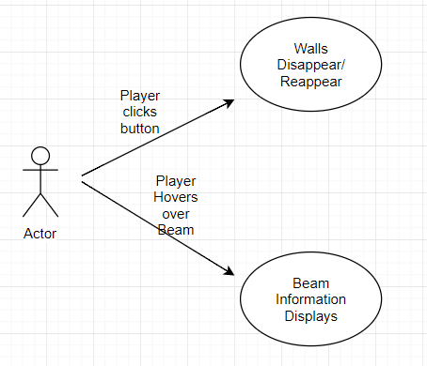

**Sequence Diagram**

**Class Diagram**

**Unit Test**

* Test case ID:
* Description/Summary of Test:
* Pre-condition:
* Expected Results:
* Actual Result:
* Status (Fail/Pass):

**Integration Test**

**Visual User Guide** <like one or two screenshots of the feature. For the hardware project, a photo of device is required>